Exercise 1: Card Dealer

In some games involving poker cards, the cards are assigned numeric values. For example, in the game of Blackjack, the cards are given the following numeric values:

* Numeric cards are assigned the value they have printed on them. For example, the value of the 2 of spades is 2, and the value of the 5 of diamonds is 5.
* Jacks, queens, and kings are valued at 10.
* Aces are valued at either 1 or 11, depending on the player’s choice.

You will create a program that uses a dictionary to simulate a standard deck of poker cards, where the cards are assigned numeric values similar to those used in Blackjack. (**In the program, we assign the value 1 to all aces.**) The key-value pairs use the name of the card as the key, and the card’s numeric value as the value. For example, the key-value pair for the queen of hearts is

'Queen of Hearts':10

And the key-value pair for the 8 of diamonds is

Your program will prompt the user for the number of cards to deal, and it randomly deals a hand of that many cards from the deck. The names of the cards are displayed, as well as the total numeric value of the hand. The program is divided into three functions: main, create_deck, and deal_cards.

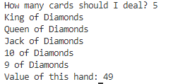

Exercise 2: Birthdays

Create a program that keeps your friends’ names and birthdays in a dictionary. Each entry in the dictionary uses a friend’s name as the key, and that friend’s birthday as the value. You can use the program to look up your friends’ birthdays by entering their names.

The program displays a menu that allows the user to make one of the following choices (validate user menu choice):

1. Look up a birthday
2. Add a new birthday (Ensure that you are checking if a name exists)
3. Change a birthday
4. Delete a birthday
5. Quit the program

The program should initially start with an empty dictionary, so you have to choose item 2 from the menu to add a new entry. Once you have added a few entries, you can choose item 1 to look up a specific person’s birthday, item 3 to change an existing birthday in the dictionary, item 4 to delete a birthday from the dictionary, or item 5 to quit the program.

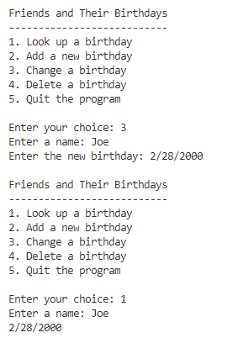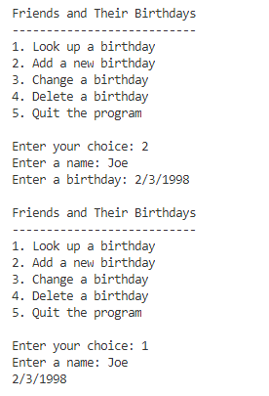

Exercise 3: President Quiz

Write a program that creates a dictionary containing the U.S. presidents as keys, and their birthplace as values. (Use the Internet to get a list of the presidents and their birthdates.) The program should then randomly quiz the user by displaying the name of a president and asking the user to enter that president’s birthplace. The program should keep a count of the number of correct and incorrect responses.

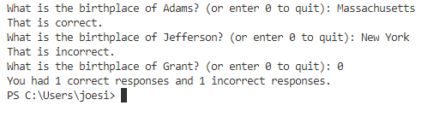

Additional Activities:

Review Sets:

<https://www.geeksforgeeks.org/sets-in-python/>

<https://www.w3schools.com/python/python_sets.asp>

Exercise 4: Duplicate Words

Using the text below create a program that will display every duplicated word in the given text. Hint: Use Sets

No one is unaware of the name of that famous English shipowner, Cunard. In 1840 this shrewd industrialist founded a postal service between Liverpool and Halifax, featuring three wooden ships with 400-horsepower paddle wheels and a burden of 1,162 metric tons. Eight years later, the company's assets were increased by four 650-horsepower ships at 1,820 metric tons, and in two more years, by two other vessels of still greater power and tonnage. In 1853 the Cunard Co., whose mail-carrying charter had just been renewed, successively added to its assets the Arabia, the Persia, the China, the Scotia, the Java, and the Russia, all ships of top speed and, after the Great Eastern, the biggest ever to plow the seas. So in 1867 this company owned twelve ships, eight with paddle wheels and four with propellers. If I give these highly condensed details, it is so everyone can fully understand the importance of this maritime transportation company, known the world over for its shrewd management. No transoceanic navigational undertaking has been conducted with more ability, no business dealings have been crowned with greater success. In twenty-six years Cunard ships have made 2,000 Atlantic crossings without so much as a voyage canceled, a delay recorded, a man, a craft, or even a letter lost. Accordingly, despite strong competition from France, passengers still choose the Cunard line in preference to all others, as can be seen in a recent survey of official documents. Given this, no one will be astonished at the uproar provoked by this accident involving one of its finest steamers.

